Programming Concepts

1. The first programming concept that I learned was If or Else statements. This is for when defining an action to do something in one case and in another case to do something else. I utilized this for displaying how many new courses were added.

2. The second programming concept that I learned about were parent nodes and children. I used this when deleting items from my list of courses. Each course was a child in the greater parent group, so one could be removed rather than the whole list.



3. The third programming concept that I learned was setting variables. I did this when trying to make a value that could later be called and saved. This is an important concept because it requires a specific syntax that is meant to assign a variable rather than compare it.



4. The fourth programming concept that I learned was the use of local storage. I used this to store information on which class section was added or unadded. I used local storage so that when the page is changed or refreshed the information would not disappear and users could continue to add or remove courses.

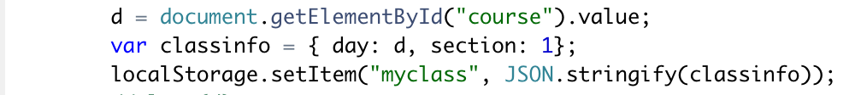

5. The fifth programing concept that I learned is pop up notifications. I used this to alert users when they have selected a new section, so that they know what day and section has been selected before they click to add section.

